Marco Seman
Program #0
CIS 310
January 17, 2018
CIS 310: PLAN OF WORK, Winter 2018

1/17/18 Prog0 due

Problem Statement:
Write a program that takes a decimal number then converts it to binary, hexadecimal, and BCD. Library functions are not allowed.

Specifications:
- Create a loop that starts from 0 and ends at 255
- Create a class for binary, hexadecimal, and BCD
- Those classes will have a set function and a constructor for each calculation.
- No library functions are allowed

Implementation:
Calculations for binary in binary set – as numbers are entered, the module of that number is taken. If its an even number, it will print out 1. If it’s an odd, it’ll print out 0. The process will reiterate itself until there is no remaining number

Calculations for hexadecimal – if the number is between 16 and 255, make a temporary storage for the future for when the number is between 0 and 15. Take the number that was entered, and divide it by 16. Round that number to the lowest int value. Next create a switch statement for the letters. If the remaining numbers are 10 – 15, have them print out their appropriate numbers. If the number is not between 10-15, then no changes are made, print out the number that was divided by 16. If the number is already less than 16, then print out 0.

Another if statement is needed for the numbers between 0 and 15. Use the module function and a similar switch statement used in the previous hexadecimal.

Converting binary to BCD – for triple digits, divide the number by 100 and round it to the lowest number. So if the number is 121, it would then be 1.21, then round it to the lowest value which is 1 since int can’t print out double figures. For the double digit function, divide the number by 10 then module it by 10.for the single digit, module the number by 10. Create a switch statement for each of them stating their appropriate case switches.

Main:
Create a while loop that reads from 0 to 255 and prints out their respective data.

Code:
// Programmer Name: Marco Seman
// CIS 310
// Professor Name: David Yoon
// Program # 0

#include "stdafx.h"
#include <iostream>
#include <math.h>
using namespace std;

// class that converts decimal to binary
class binary
{
private:
int bin;

public:
binary()
{
bin = 0;
}

void setBinary(int b)
{
int rem;

// couts the number if its less than or equal to 1
if (b <= 1)
{
cout << b;
return;
}

rem = b % 2; // module the user's entry by 2
setBinary(b >> 1); // repeat the set binary sequence until b(decimal entered) is 0
cout << rem;
}
};

// convert decimal to hexidecimal
class hexidecimal
{
private:
int hex;
int k;
public:
hexidecimal()
{
hex = 0;
}

// when user enters decimal (h) convert that decimal here
void setHex(int h)
{
// "a" is only used as a temparary storage for the remaining int
// num is the remainder
int num, a;
/*
// 4096 through 65536
if (h >= 4096 && h < 65536)
{
a = h % 4096; // remainder for 4096
num = floor(h / 4096); // round to the lowest whole int
if (num > 9) // if the number is between 9 and 15, it prints the character
{
switch (num)
{
case 10: cout << "A"; break;
case 11: cout << "B"; break;
case 12: cout << "C"; break;
case 13: cout << "D"; break;
case 14: cout << "E"; break;
case 15: cout << "F"; break;
}
}
// if it's less than 9
else
{
cout << num;
}
// place the module of 4096 in h to be used in the next sequence
h = a;
}
// always cout "0" in case it passes through this sequence
else
{
cout << "0";
}

// 256 through 4096
if (h >= 256 && h < 4096)
{
a = h % 256; // remainder of 256
num = floor(h / 256); // round to the lowest int
if (num > 9) // same as before
{
switch (num)
{
case 10: cout << "A"; break;
case 11: cout << "B"; break;
case 12: cout << "C"; break;
case 13: cout << "D"; break;
case 14: cout << "E"; break;
case 15: cout << "F"; break;
}
}
else
{
cout << num;
}
// place the module of 256 in h
h = a;
}
// place a 0 in case it skips this sequence
else
{
cout << "0";
}
*/
// 16 through 255
if (h >= 16 && h < 256)
{
a = h % 16; // remainder of 16
num = floor(h / 16); // round to the lowest int
if (num > 9)
{
switch (num)
{
case 10: cout << "A"; break;
case 11: cout << "B"; break;
case 12: cout << "C"; break;
case 13: cout << "D"; break;
case 14: cout << "E"; break;
case 15: cout << "F"; break;
}
}
else
{
cout << num;
}
// place the remainder of 16 back into h
h = a;
}
// print the 0 incase it skips this sequence
else
{
cout << "0";
}

// 0 through 15

if (h > 0 && h < 16)
{
num = h % 16;

if (num > 9)
{
switch (num)
{
case 10: cout << "A"; break;
case 11: cout << "B"; break;
case 12: cout << "C"; break;
case 13: cout << "D"; break;
case 14: cout << "E"; break;
case 15: cout << "F"; break;
}
}
else
{
cout << h;
}
}
else
{
cout << "0";
}
}

};

// convert decimal to bcd
class BCD : public binary
{
private:
int bcd;

public:
BCD()
{
bcd = 0;
}
// convert decimal to BCD 1 - 255
void setBCD(int B)
{
// s = single digit, d = double digit, t = triple digit
int s, d, t;

t = floor(B / 100);
d = floor(B / 10);
d = d % 10;
s = B % 10;
d = (B / 10) % 10;

switch (t)
{
case 0: cout << "0000 "; break;
case 1: cout << "0001 "; break;
case 2: cout << "0010 "; break;
}
switch (d)
{
case 0: cout << "0000 "; break;
case 1: cout << "0001 "; break;
case 2: cout << "0010 "; break;
case 3: cout << "0011 "; break;
case 4: cout << "0100 "; break;
case 5: cout << "0101 "; break;
case 6: cout << "0110 "; break;
case 7: cout << "0111 "; break;
case 8: cout << "1000 "; break;
case 9: cout << "1001 "; break;
}

switch (s)
{
case 0: cout << "0000 "; break;
case 1: cout << "0001 "; break;
case 2: cout << "0010 "; break;
case 3: cout << "0011 "; break;
case 4: cout << "0100 "; break;
case 5: cout << "0101 "; break;
case 6: cout << "0110 "; break;
case 7: cout << "0111 "; break;
case 8: cout << "1000 "; break;
case 9: cout << "1001 "; break;
}

bcd = B;
}
};

int main()
{
// Wasn't sure what you wanted. the commented out section will compute a number writen by the user

/*
int decimal;
cout << "Enter a number to convert to Binary, Hexidecimal, and BCD" << endl;
cin >> decimal;

while (decimal < 0 || decimal > 255)
{
if (decimal < 0 || decimal > 255)
{
cout << "Enter a value between 0 and 255" << endl;
cin >> decimal;
}
}
*/

binary b;
hexidecimal h;
BCD d;

/*
cout << "Value for Binary: ";
b.setBinary(decimal);
cout << endl << endl;

cout << "Value for Hexidecimal: ";
h.setHex(decimal);
cout << endl << endl;

cout << "Value for BCD: ";
d.setBCD(decimal);
cout << endl;
*/

cout << "Decimal Binary Hexidecimal BCD" << endl;

int decimal = 0;
// a loop that ends after 255
while (decimal <= 255)
{
cout << decimal << " ";
b.setBinary(decimal);
cout << " ";
h.setHex(decimal);
cout << " ";
d.setBCD(decimal);
cout << endl;
decimal++;
}

return 0;
}

Screenshots:

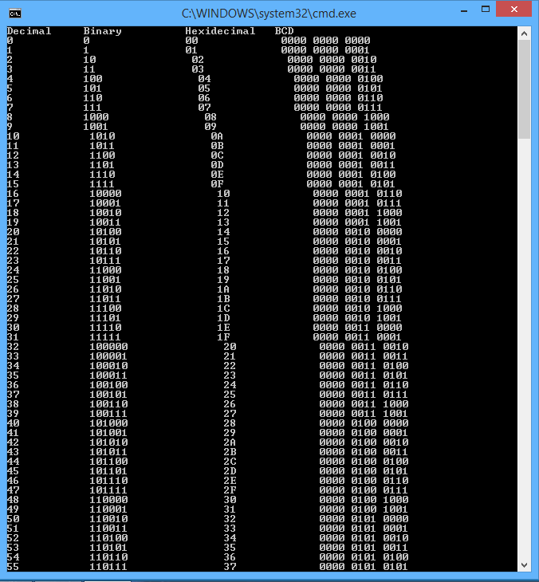

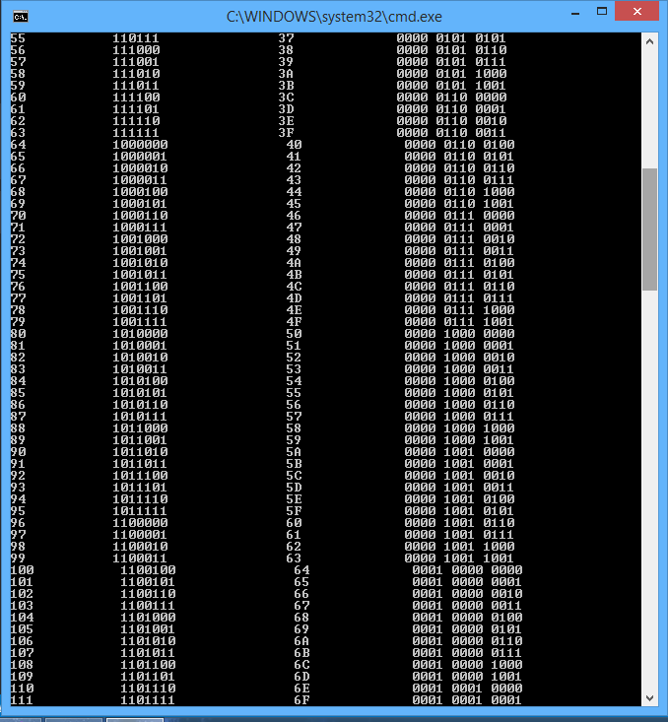

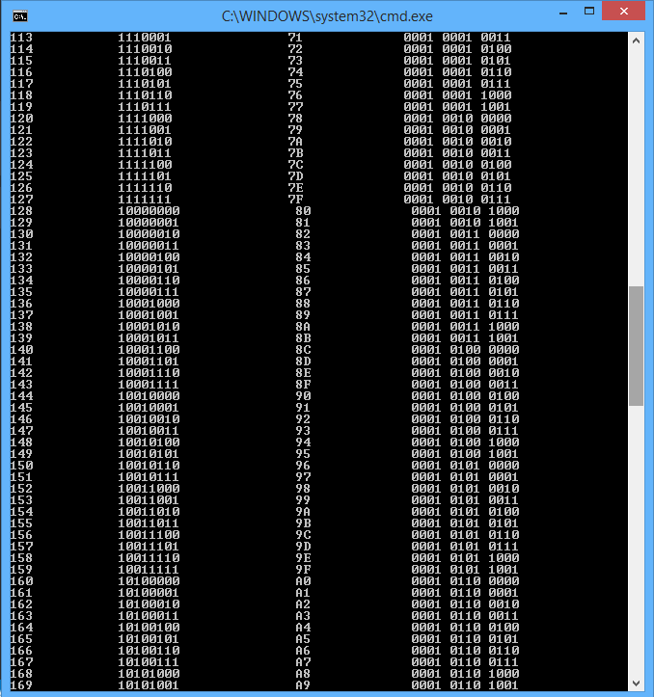

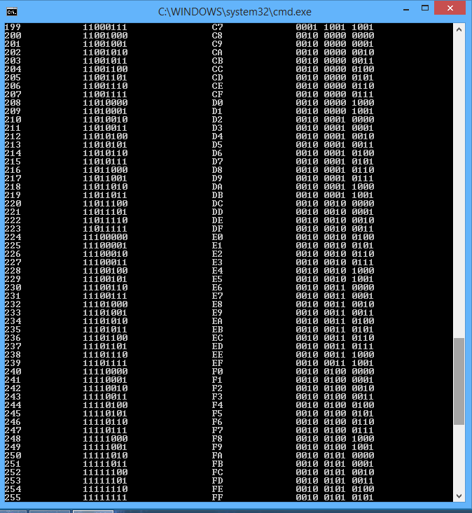

End.

